**Prueba técnica**

We have an online app for a HR department, based on MVC architecture. Its URL can be something like: myhrapp.com

It is needed to implement a new endpoint in the backend that, given a country id (see SQL structure below), returns a paginated list of departments located there, with at least this information for each: Department name, city and list of employees: first name and last name.

Extra ball would be return departments ordered by its average payed salary, descending.

What we need from you is:

- Implement API class for the REST end-point in myhrapp.com/api/v1/CONTRIES/{id}

- Implement classes and needed methods for involved entities

Notes:

* You can implement the solution using legacy PHP or based on any PHP framework - Symfony would be the best considered ;)

This is the example structure in DB:

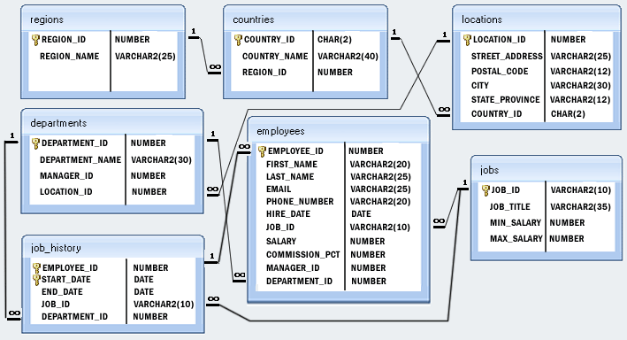

Download example SQL:<http://www.w3resource.com/mysql-exercises/db.sql>